Mongo DB

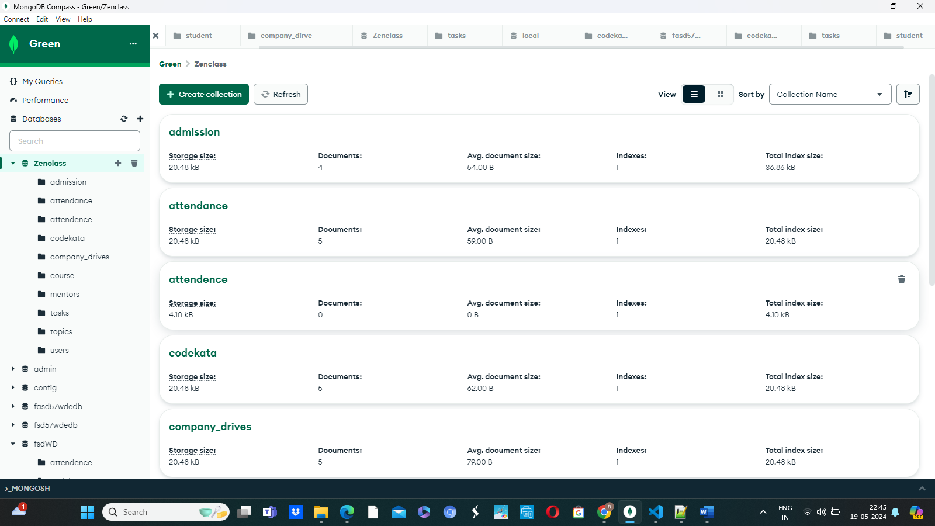

Use Zenclass;
Db.createCollection(adminssion);
Db.createCollection(users);
Db.createCollection(tasks);

Db.createCollection(topics);

Db.createCollection(companyDrive);
Db.createCollection(attendence);

Db.createCollection(codekata);

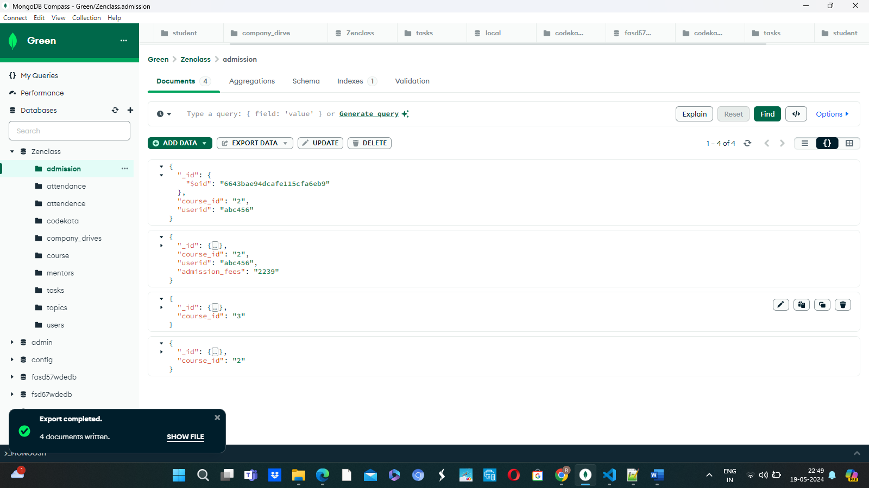

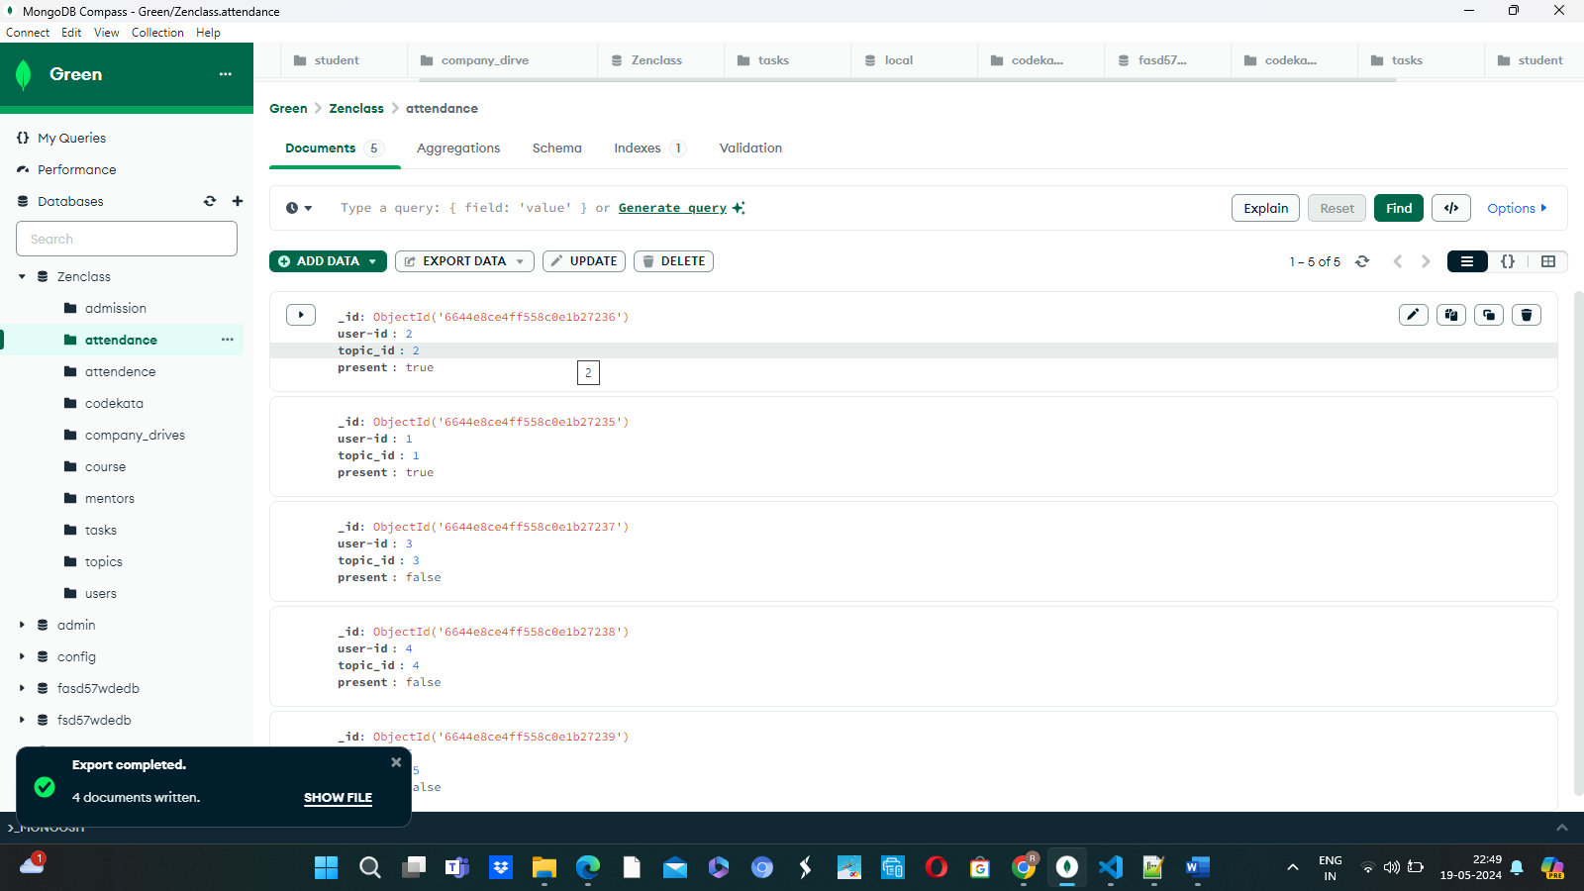

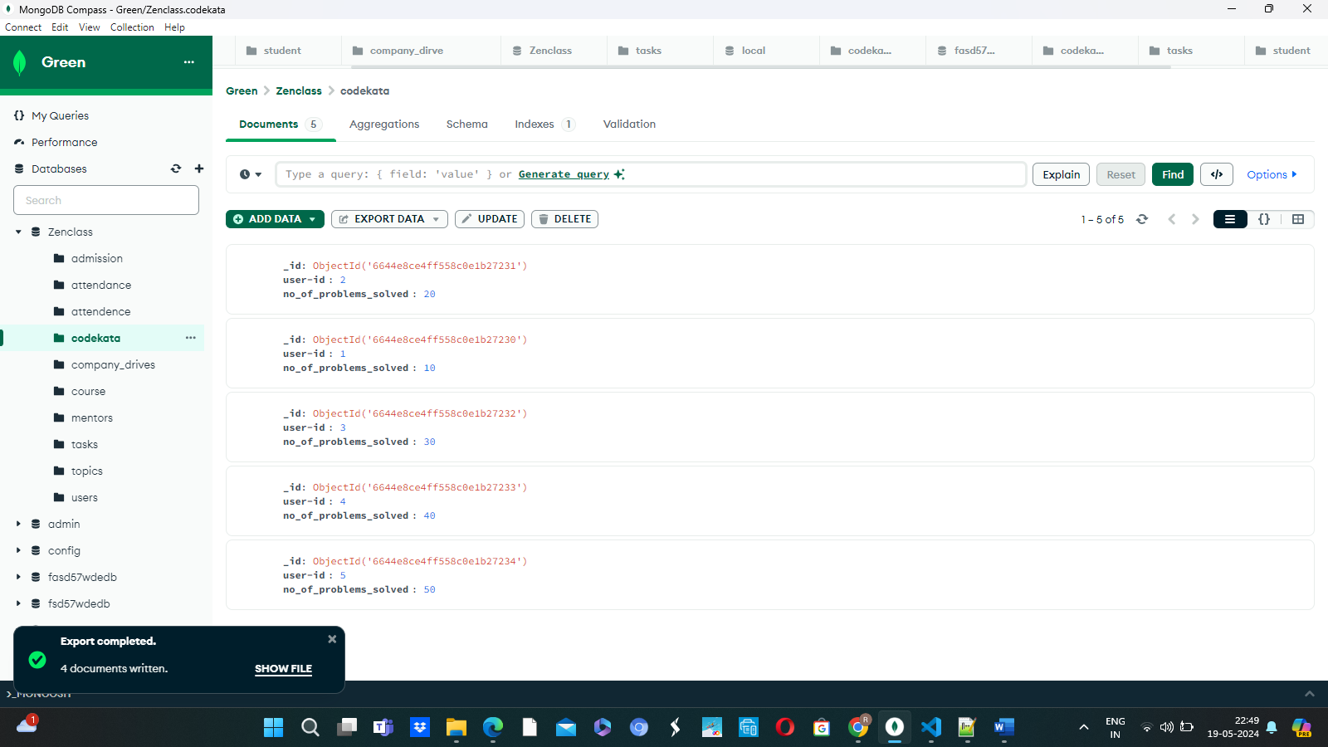

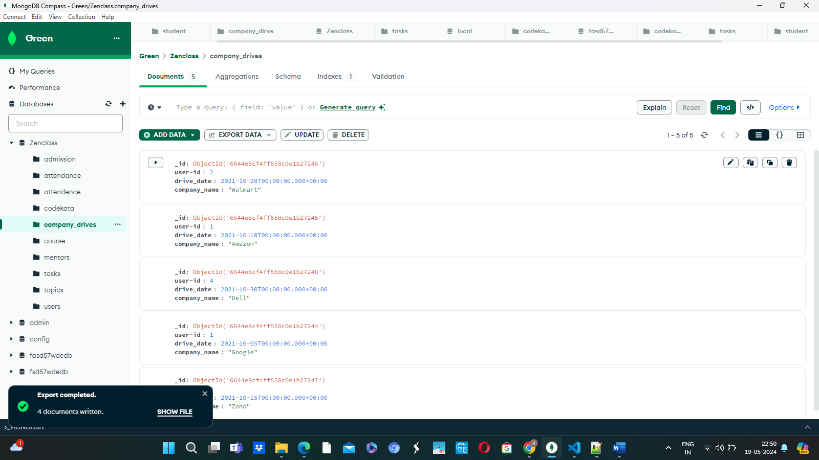

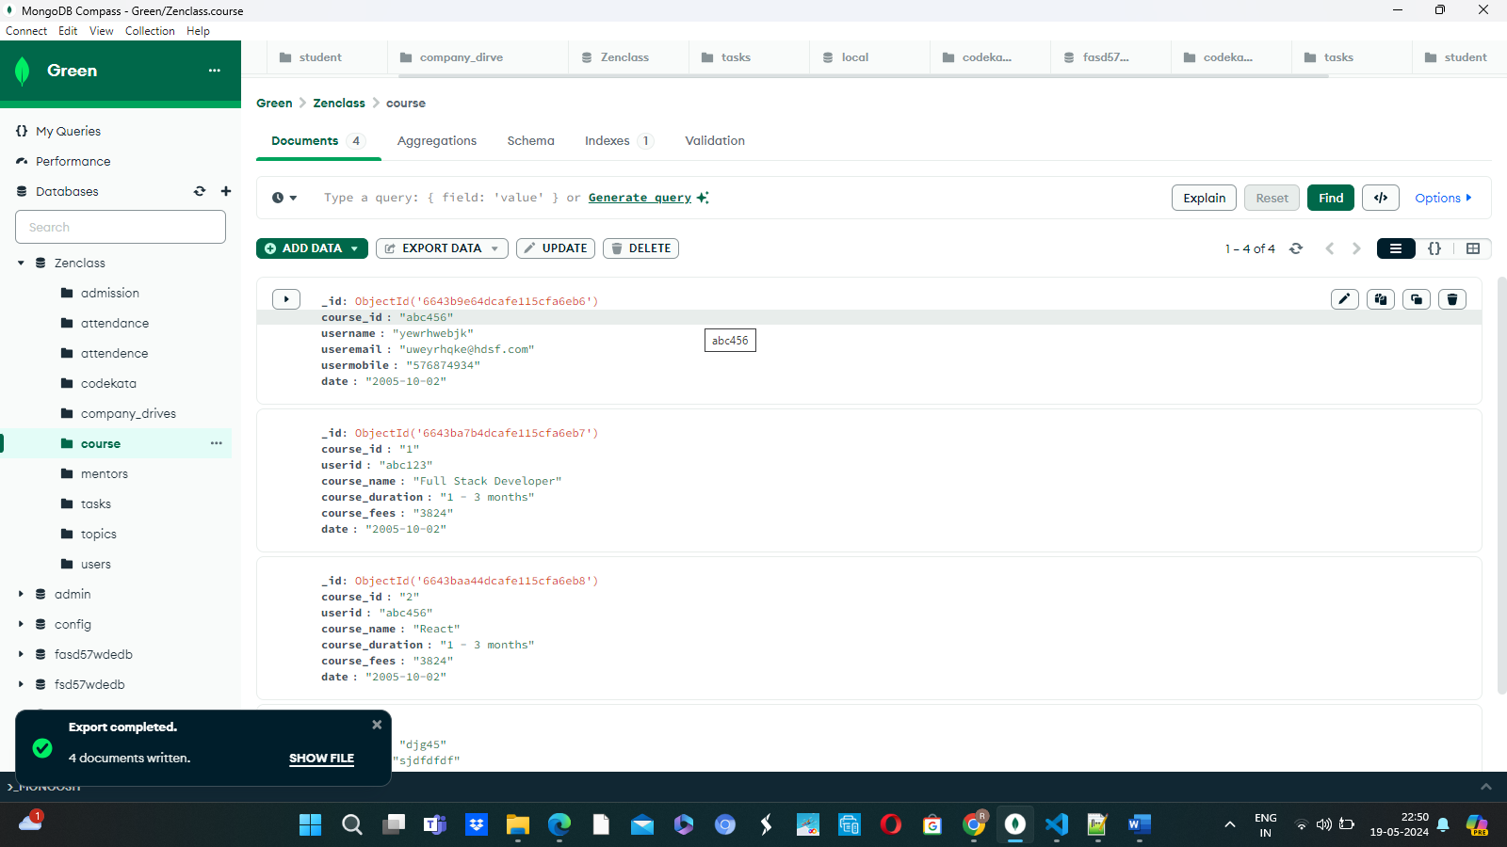

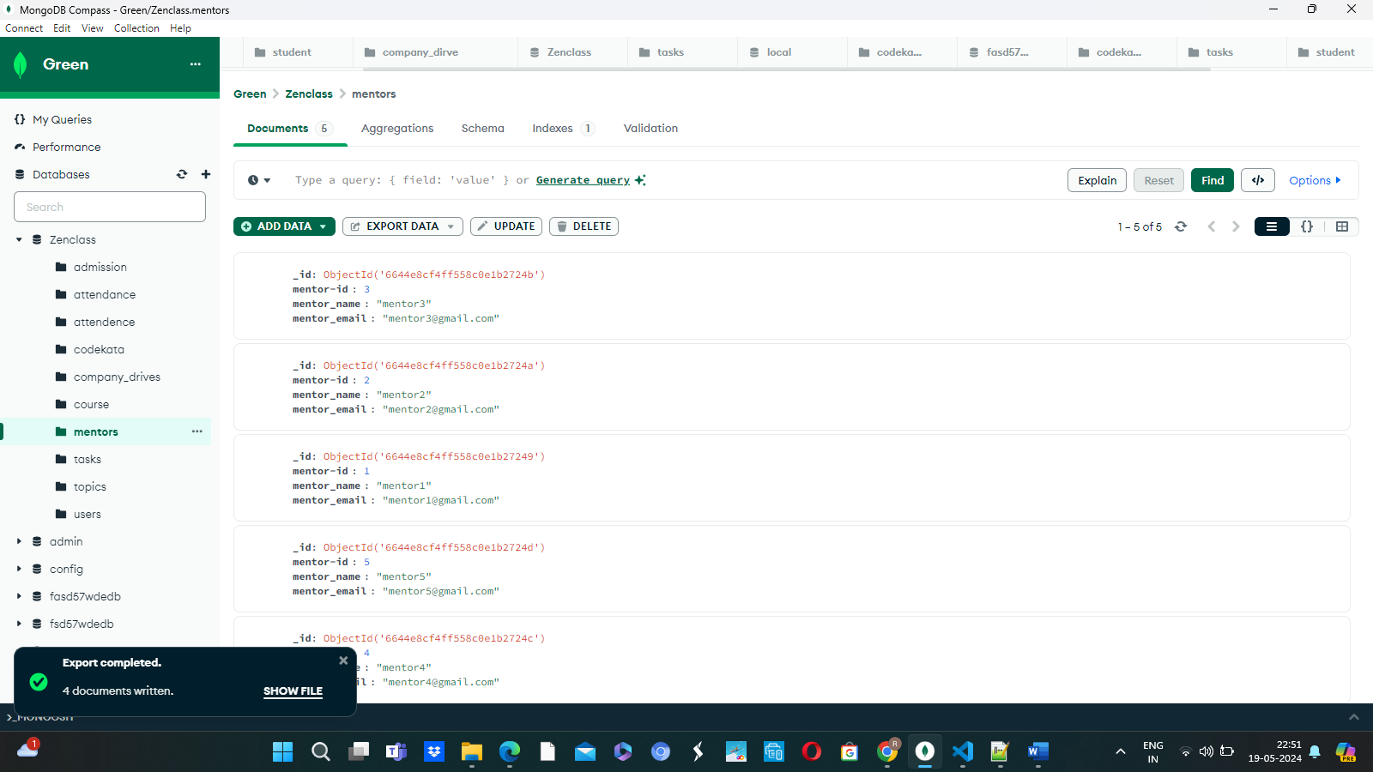

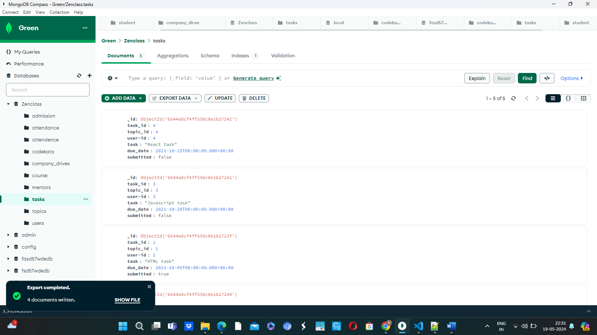

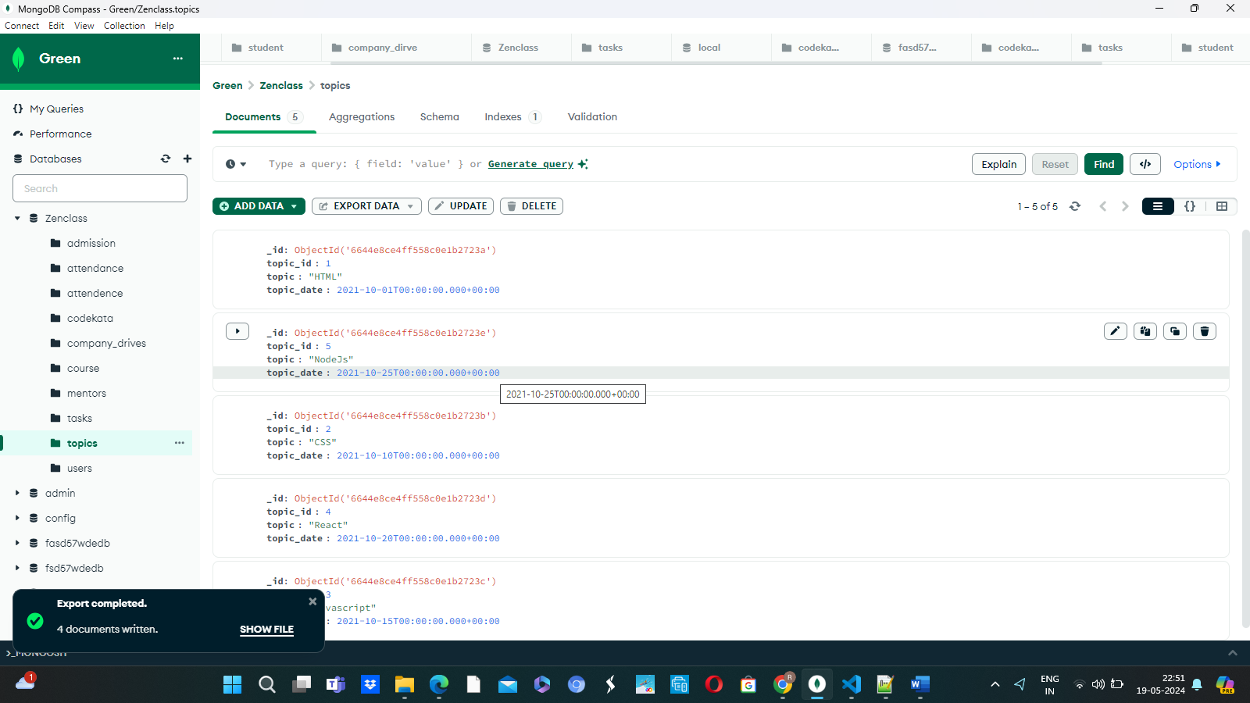

1.db.topics.aggregate([ {$match:{$and :[ { "due":{ $gte:new Date('2021-10-01'),$lte:new Date('2021-10-30')}}]} }]);

2.db.company_drive.aggregate([ {$match:
{
$and :[ {
"date":{
$gte:new Date('2021-10-15'),
$lte:new Date('2021-10-31')
}}]
}}]);

3.db.student.aggregate({$lookup : {from:"company_drive",localField:"_id",foriegnField:"compID",as:"result"}})

4.

db.codekata.aggregate([{$lookup : {from:"student",localfield:"_id",foreignField:"user-id",as:"result"}},{$project :{ "_id":0,"user-id":1,"no_of_problem_solved":1,"result.studentname"}}]);

5. db.mentors.find({mentee_count:{$gte:15}});
5. db.companydrives.aggregate([
{
$lookup: {
from: “users”,
localField: “userid”,
foreignField: “userid”,
as: “info”,
},
},
{
$project: {
_id: 0,
company: 1,
drive_date: 1,
“info.name”: 1,
“info.email”: 1,
“info.userid”: 1,
},
},
])

